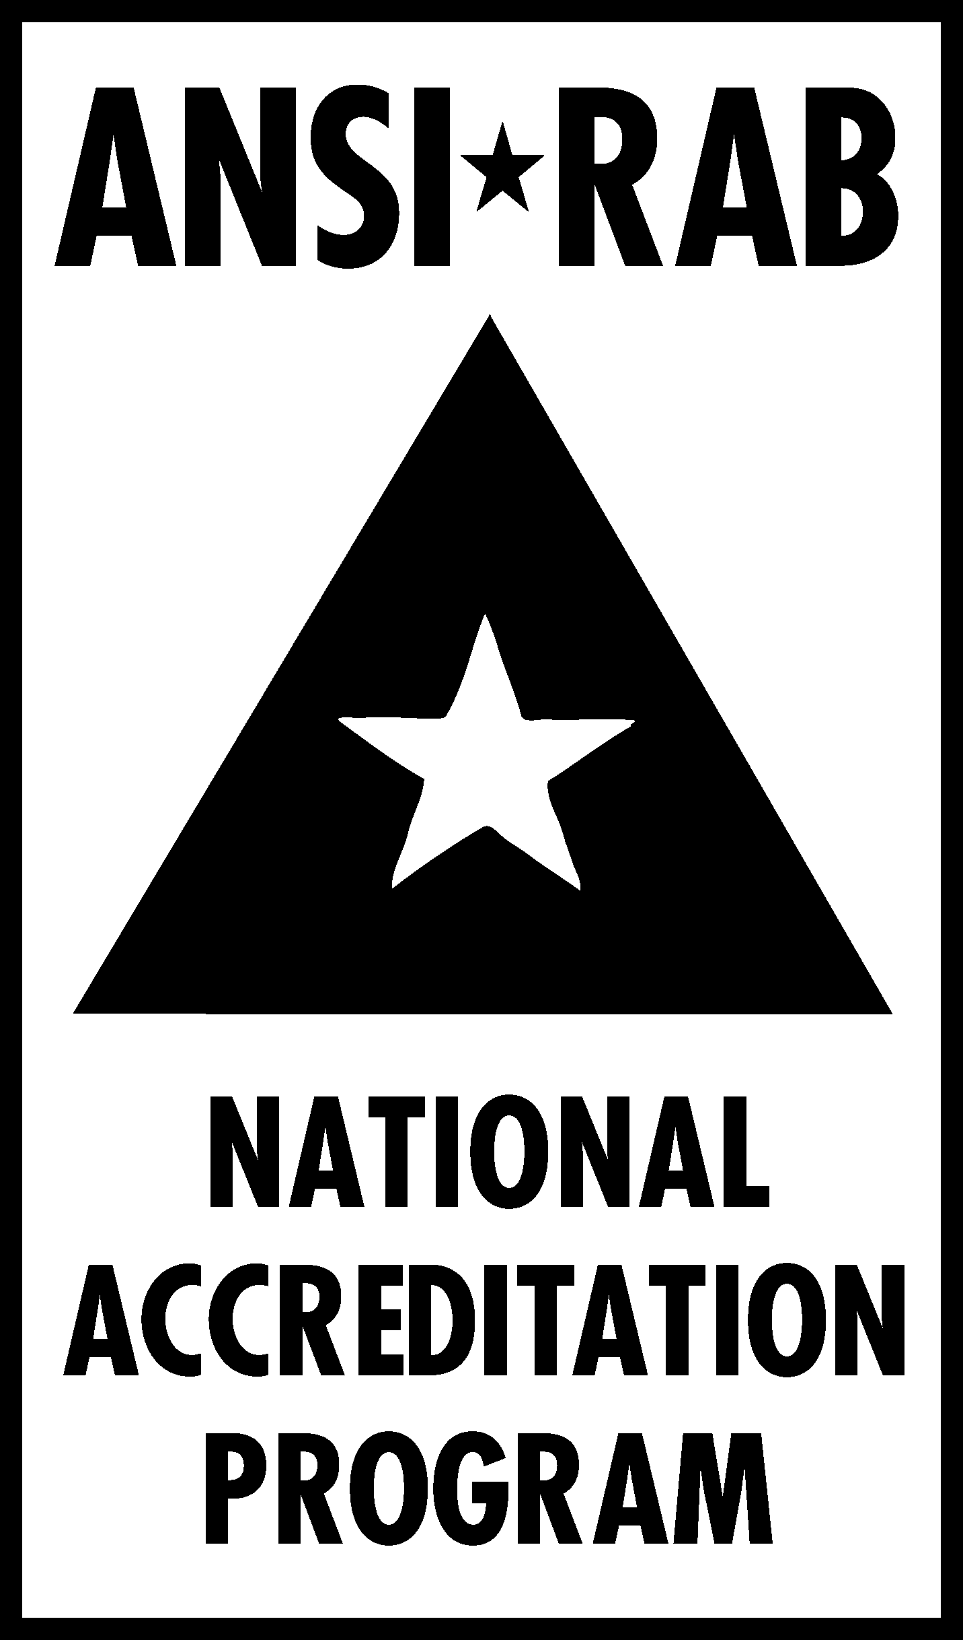 | NEWS RELEASE
FOR IMMEDIATE RELEASE Media contact:
November 30, 2004 Penny Fredrick, 888-722-2440
pfredrick@rabnet.com

ANSI-ASQ National Accreditation Board to Replace ANSI-RAB NAP
Milwaukee – The American National Standards Institute (ANSI) and the American Society for Quality (ASQ) have agreed to form a new American national accreditation body. The ANSI-ASQ National Accreditation Board (ANAB) will replace the ANSI-RAB National Accreditation Program (ANSI-RAB NAP) as of January 1, 2005.
ANAB was formed in response to the adoption of ISO/IEC 17011, Conformity assessment – General requirements for accreditation bodies accrediting conformity assessment bodies, which requires that a national accreditation body be a legal entity. The ANSI-RAB NAP as currently structured does not meet that requirement. ANAB will also be divorced from RAB’s personnel certification programs, as ISO/IEC 17011 prohibits a body from engaging in both accreditation and certification activities.
By meeting the requirements of ISO/IEC 17011, the American accreditation body will satisfy concerns within the International Accreditation Forum (IAF), the global organization of national accreditation bodies, and remain in good standing as a signatory to the IAF multilateral recognition arrangements for both quality and environmental management systems.
Certification/registration bodies (CRBs) accredited by the ANSI-RAB NAP will automatically convert to ANAB accreditation as of January 1, 2005. ANSI-RAB NAP-accredited CRBs will receive the new ANAB accreditation mark for use with their registered clients. New certifications issued by accredited CRBs after January 1, 2005, should carry the ANAB mark. Existing certificates will be revised on the clients’ existing recertification schedules.
(more)
No change in staffing for existing NAP programs is anticipated. However, the accreditation staff has reorganized to better focus on customer needs in advance of implementing the ANAB agreement. Operations will continue to be based in Milwaukee. New contact information (telephone, fax, Web site, and e-mail addresses) will be provided as soon as they are available.
The agreement to create ANAB was approved by ASQ’s Board of Directors on November 5, 2004, and ANSI’s Executive Committee approved the pact on November 18, 2004. Final approval is expected when ANSI’s board ratifies the agreement at its mid-December meeting.
# # # # #

